**31. What does a feature file contain?**

A feature file is the file which contains **feature , scenarios and feature description to be tested**

**32. What are the two sections of the feature file?**

**a)Feature**

**b) Scenario / Scenario Outline**

**33. What are the keywords used in the Feature file?**

**Feature**

**Scenario**

**Scenario Outline**

**Given**

**When**

**Then**

**And**

**\***

**Examples**

**Background**

**34. What is Feature in feature file?**

**Feature is Keyword**

**Feature :**  Feature file begins with a feature keyword which tells about the module / project which are testing

Feature keyword does not affect the behaviour of the cucumber test

Feature : gives some convenience place to put some summary of document for test / group of test cases

Feature file must be followed by one of the following

1. Scenario
2. Scenario Outline
3. Background

Example : **Feature** : Login functionality of facebook

**35. Provide an example of a feature file using the Cucumber framework.**

Example : Login functionality

**Given** : User on login page

**When** : User enters username and password

**Then** : User on the Homepage

**36. What is Scenario?**

Each cucumber test is called a scenario and each scenario contains some steps , that tells what scenario is like a test case which starts with keyword scenario

1. A text which is immediately follows after scenario keyword is title (test case description)
2. To fulfil the business requirements all the scenarios contains the following

**Precondition :** This is the state where the test case can be executed , precondition are mentioned in the **given** keyword , **given keyword** may contain multiple preconditions

**UserAction :** This is the state where users perform an action.User actions are mentioned in the When keyword , scenario can have multiple user actions.

Which means when keyword can be multiple

**Expected output :** This is the state where applications give response ,expected output are mentioned in **Then**  keyword. A scenario can have multiple results.

**Note** : A scenario contains steps which are equivalent to Test steps

c)All scenarios perform following actions

i)Get the system into particular state

ii)Perform some action

iii) Examine the new stare

**37. How Scenario Works?**

When cucumber runs a scenario , if the system behaves as described in the scenario , then scenario will pass , if not then it will fail. Every time we add a new scenario and make it pass.

**38. What should we use in a feature file single scenario or multiple scenarios ?**

A feature file can be used for single scenario or multiple scenarios based on project requirement

**39. What should you keep in mind when you use multiple scenarios in a single feature file?**

A feature file either have single scenario or multiple scenarios, we should keep these following points when we use multiple scenarios in the feature file.

1. If you are using multiple scenarios , then take care that all the scenarios are independent
2. Scenarios must not be dependent on each other
3. The result of one scenario should not affect the other scenario.

**40. What is the language used to write a scenario in a feature file?**

Gherkin

**41.What are keywords that are used in cucumber for writing a scenario ?**

**Given**

**When**

**Then**

**And/But**

**42.What is the starting point of execution for feature files?**

To run the feature file , we have to create the test runner class.

The starting point of the execution of a feature file is from the Test Runner class when the feature file is integrated with selenium.

We cannot run the feature file , from feature file section ,we have to use test runner class.

**43.How to comment a line in a feature file?**

To comment any line in a feature file , we will use #

**44.What is the right way to execute a specific scenario from the feature file?**

**By using Tags**

**45.What is the limit for the maximum number of scenarios that can be included in a feature file?**

Count depends on the project to project and organisation to organisation , standard format is 10

**46.What is the classpath separator ?**

The colon : written after feature ,scenario or scenario outline is called as class path parameter , without which feature file will not work

**Example**

**Feature**: Login functionality

**Scenario**: Verify login functionality

**Given** User on Facebook login page

**When** User enter valid username and password

**Then** user on HomePage

**47.What are cucumber plugins** ?

Cucumber plugins allow you to customise how tool behaves

The plugins that ship with cucumber produce various output formats that record what happened in a test run.

These are plugins that produce HTML reports , plugins that produce JUnit XML for continuous integration servers like Jenkins and many more .

**48.Explain the Given keyword in cucumber ?**

**Given** : **Given** is used to put our application in a well known state before making any execution process.

This keyword puts the system in a know state before the user (or external system ) starts interacting with the system

Given user on facebook login page

**49.Explain about when keyword in cucumber ?**

When a step represents the key action , the user performs. The action usually has an observable effect somewhere else.

Or

By using when , you can define the action

**50.Explain about then keyword in cucumber ?**

Then : Then step observes and validates the outcome , it is an assertion sentence just like the assert statement in common unit testing frameworks.

Then the sentence should be related to the business value/benefit in your feature description.

Then verify the outcome of the scenario

**51.Explain about the And / But keyword in cucumber ?**

**And ,But :** This is used when we have multiple Given/When/Then steps . To avoid the repetition of Given/When/Then we can use And,But

By using And and But we can increase the readability and expressiveness of the scenario.

**52.What is the difference between And/ But keyword in cucumber ?**

**And /But :** This is used when we have multiple Given/When/Then steps. To avoid the repetition

Of Give, When ,Then we can use And/But

**Differences:**

Then is used for the statements that are an addition to the previous steps and represent positive statements.

But is used for the statements that are an addition to the previous steps and represent negative statements

**Example**

**Scenario:** Verify login functionality of facebook

Given User on facebook page

When User enters username and password

Then User on Homepage

And User clicks on user tab

Then User logout from facebook

**Scenario:** Verify login functionality of facebook

Given User on facebook page

When User enters username and password

Then User on Homepage

And User clicks on user tab

But Logout button is not available

**53.What is the common between And/But in a feature file ?**

1. By using these (And , But ) we can increase the readability and expressiveness of the scenario
2. **And & But are not found in step definition files**

**You will never get And But in step definition**

**54.What is the difference between Give, When , Then steps in a feature file ?**

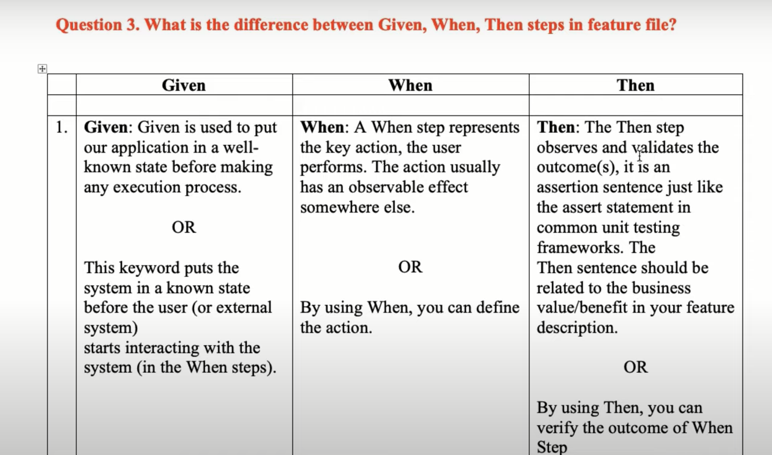

**55.What is a Scenario Outline ?**

Scenario Outline : This keyword is basically replacing the variable /keywords with the value

From the table , each row in the table is a scenario

The Scenario Outline steps provide a template which is never directly run , A Scenario Outline is run once for each row in the Examples section (not counting first row )

**Note :** For Scenario Outline it is mandatory to write  **Examples**

Feature: Verify Facebook login

Scenario Outline : Login message with valid login credentials

Given user on facebook

When user enter valid “<username >” and “ <password>”

Then user successfully logged in

**Examples :**

**|username|password|**

**|sravan|test123| – placeholder – this will repeats it placeholders are available**

**|anil|test1234|**

**How Examples works ?**

This works via placeholder , Placeholder must be contained with <> in Scenario Outline steps

**NOTE :** Your Step definitions will never have to match a placeholder. They will need to match the values that will replace the placeholder

**56.What is the meaning of Scenario Outline available in the feature file ?**

Scenario Outline available in the feature file means we are passing different values in scenario

Steps , that will run again and again till place holders are available in Examples

**57.What is the use of Scenario Outline in the feature file ?**

If we want to run the same test case for different inputs again and again then we use Scenario Outline it the placeholders are available in the Example

Scenario we have to write multiple times ,

**58.What is the purpose of the Scenario Outline in the feature file?**

1. Scenario Outline is used to stop copy and paste the same Scenario (Having same steps with different values)
2. If we are not using scenario Outline and copying and pasting the same scenario ,as it will increase the maintenance

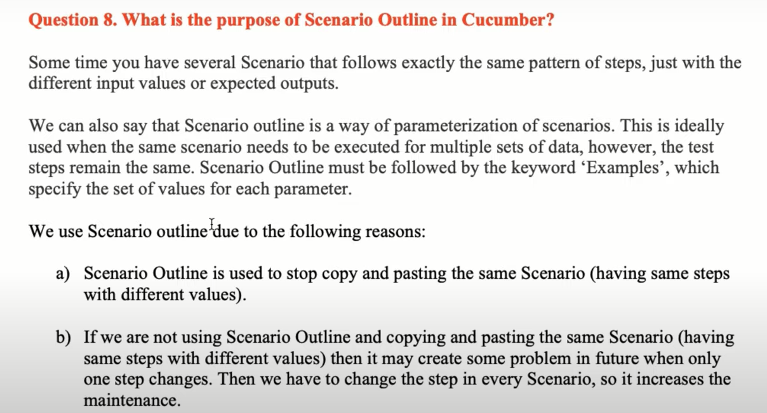

**59.Explain about Examples in Cucumber ?**

Example is a keyword word used with Scenario OUtline to pass different values to the same scenario step.

Example contains two important things

Pipe Symbol

Placeholders

**60.What is the purpose of the Examples keyword in Cucumber ?**

Example keyword helps you to pass different inputs for a same test case, we can run the same test case multiple times

**Difference between scenario and scenario Outline ?**

In Gherkin language, scenario outline is the keyword which is used to run the same scenario multiple times. ... In other words, the keyword Scenario Template is a synonym of scenario outline. Scenario outline is exactly similar to the scenario structure, but the only difference is the provision of multiple inputs.